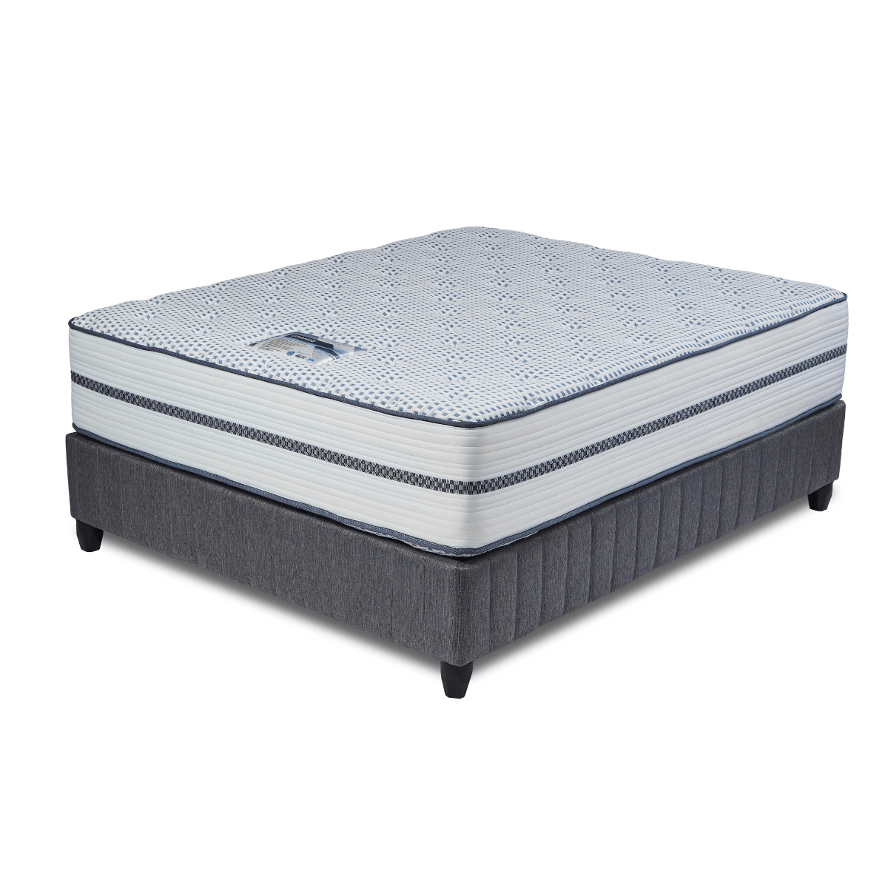


Model : Grande Bed Set
Supplier/Manufacturer : Cloud Nine
Range : Ultra Premium
Prices – Bed Set :
- Single Bed Set – R12589
- Three Quarter Bed Set – R14279
- Double Bed Set – R17179
- Queen Bed Set – R18659
- King Bed Set – R22689
Prices – Mattress Only :
- Single Mattress Only – R10939
- Three Quarter Mattress Only – R12449
- Double Mattress Only – R15149
- Queen Mattress Only – R16579
- King Mattress Only – R19379
Prices - Extra Length Bed Set :
- Single Extra Length Bed Set – R13599
- Three Quarter Extra Length Bed Set – R15429
- Double Extra Length Bed Set – R18559
- Queen Extra Length Bed Set – R20159
- King Extra Length Bed Set – R24509
Prices - Extra Length Mattress Only :
- Single Extra Length Mattress Only – R11819
- Three Quarter Extra Length Mattress Only – R13449
- Double Extra Length Mattress Only – R16359
- Queen Extra Length Mattress Only – R17909
- King Extra Length Mattress Only – R20929

*Please use this link for guideline for creating the page* - https://www.bedsonline.co.za/product/cloud-nine-grande-queen/
Cloud Nine Link - https://cloudnine.co.za/ultra-premium/grande/

